Theoretical Background

# Possible Measurement approaches

The light “decays” as it propagates through the water, with attenuation coefficient depending on (among other factors) wavelength, and water properties such as molecular structure, saltiness, phytoplankton concentration.

## Beam Attenuation:

Measuring the attenuation of light in a specific wavelength over a known distance it is possible to extract the attenuation coefficient and predict the visibility in that water body.

To use this method we suggest the setup used in the paper [In Situ Target-Less Calibration of Turbid Media](https://www.viseaon.haifa.ac.il/_files/ugd/acdb85_708d3fc222fa492d8e7d2c26f2b5fd5e.pdf) in paragraph *4.2. Target-Less (TL) Calibration: Attenuation:*

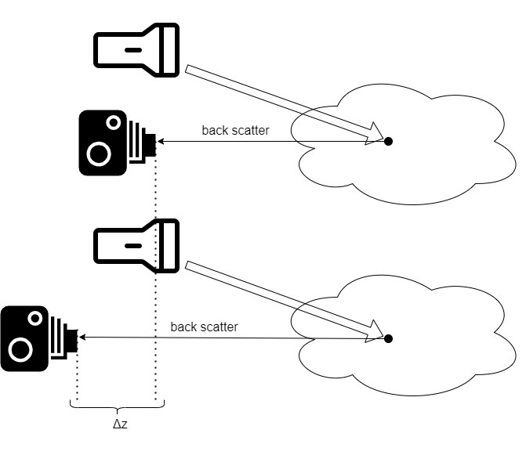

We denote the image in upper setup as $B_{∞}^{I}\left(x=0\right)$ and second image as $B_{∞}^{II}\left(x=0\right)$. Then the coordinates difference dictates $R_{cam}^{II}\left(X^{'}\right)=Δz+R_{cam}^{I}\left(X^{'}\right)$, therefore according to the RTE:

$$B_{∞}^{II}\left(x=0\right)=\exp\left(-c⋅Δz\right)⋅B_{∞}^{I}\left(x=0\right)$$

Then for each color channel $k$:

$$c^{\left(k\right)}=-\frac{1}{Δz}\ln\left(\frac{{\left(B_{∞}^{II}\right)}^{\left(k\right)}}{{\left(B_{∞}^{I}\right)}^{\left(k\right)}}\right)$$

## Secchi Disk:

In this method, a disk is lowered vertically from water level to the point it cannot be observed anymore. The Secchi Disk reading provides a quantitative estimation for $c+K$, water optical properties: $c$– the beam attenuation coefficient, and $K$– the diffuse attenuation coefficient, both in $\left[m^{-1}\right]$, however the ability to separate the two factors is limited.

To simulate this method, we need to generate water surface and deep-water body volume, then render a Secchi Disk with the proper dimensions and texture in various depths.

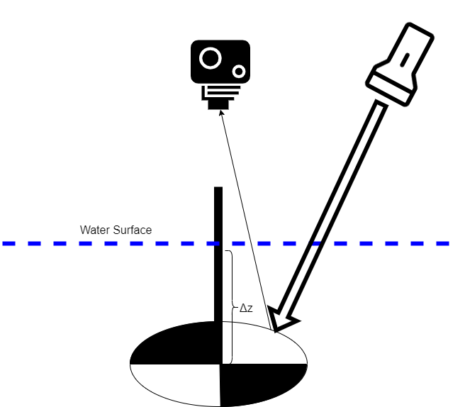

As $Δz$ is the disappearing depth of the disk:

$$Δz=\frac{\ln\left(\frac{C_{0}}{C_{T}}\right)}{c+K}$$

$C_{0}$ and $C_{T}$ represent the apparent contrast of the disk in water level and in the max visible depth.

## Black Disk Attenuation:

Can be used like Secchi Disk, but the black hue eliminates dependency on view angle, and keeps relative brightness contrast of the disk to background constant.

Another approach is to perform horizontal measurements using the black disk and a specialized apparatus that enables the observer (sensor) to be above water level while viewing the disk horizontally in the water through a submerged mirror

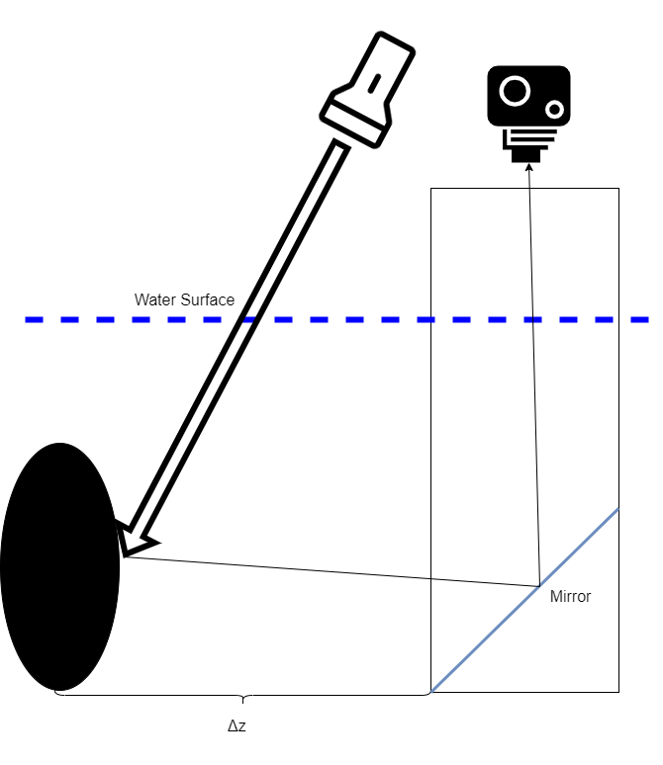

In the horizontal viewing approach only the beam attenuation coefficient can be by:

$$Δz=\frac{\ln\left(-\frac{1}{C_{T}}\right)}{c}$$

When $Δz$ is the maximal visual range.

To simulate this method, we can recreate the Secchi Disk simulation, only this time with a black disk. Otherwise, to simulate the horizontal measurement method we need to simulate the water environment, the viewing apparatus, and the disk in various distances.

## Methods Comparison:

|  |  |  |  |
| --- | --- | --- | --- |
| Method name | Sensor position | Estimated parameter | Required water depth |
| Secchi Disk | Above water level | $$c+K$$ | Deep enough for the disk to disappear (in some cases may take ~60m). |
| Beam Attenuation | Below water level | $$c$$ | Does not require large depth but does require very large distance to edges or the water (no target should be in sight range). |
| Black Disk Attenuation | Above water level | $c+K$ in vertical measurement $c$ in horizontal measurement $c,K$ if both methods applied | Like Secchi Disk for vertical measurements,  Horizontal measurements are suitable for relatively shallow water. |

# Physical properties:

## Radiative transfer function:

The physical phenomenon of energy transfer in form of EM radiation, the radiance of the energy is affected by absorption, emission, and scattering processes. The radiance $L(r;ξ)$ in position $r$ propagation in direction $ξ$ in an absorbing, scattering, and emitting 3D medium is mathematically described in radiative transfer equation (RTE):

$$\underset{(a)}{\left(ξ⋅∇\right)L\left(r;ξ\right)}=-\underset{\left(b\right)}{c\left(r\right)L\left(r;ξ\right)}+\underset{\left(c\right)}{\int_{Ω}{L\left(r;ξ^{'}\right)β\left(r;ξ^{'}→ξ\right)dΩ^{'}}}+\underset{(d)}{S\left(r;ξ\right)}$$

Where $r$ is the position vector in cartesian coordinates, $ξ$ is the direction unit vector, $c\left(r\right)$ is the attenuation coefficient, $β\left(r;ξ\right)$ is the volume scattering function (VSF) – describing the probability of radiance in position $r$ with any direction $ξ'$ to be scattered in direction $ξ$, $S\left(r;ξ\right)$ represents emissions from internal radiance source.

## Rayleigh scattering:

Dispersion of EM radiation through particles with radius less than ~ $\frac{1}{10}$ the wavelength of the incident radiation, named after Lord Rayleigh, who described this phenomenon in his paper from 1871, this effect explains why the sky having blue color.

The formula for Raileigh Scattering is given by:

$$I=I_{0}\frac{8π^{4}Nα^{2}}{λ^{4}R^{2}}\left(1+\cos^{2}{θ}\right)$$

Where $I_{0}$ is the initial intensity, $N$ is the no. of scatterers, $α$ is polarizability, R is the distance from scatterer, $λ$ is the wavelength and $θ$ is the scattering angle.

## Mie scattering:

The predominate scattering regime for particles with radius $R$ that satisfies $\frac{2πR}{λ}≈1$. Mie scattering is almost independent on wavelength, but it depends on the radius of the particle, as well as in the dielectric and magnetic permeabilities of the scattering material. Unlike Rayleigh Scattering, Mie Scatter pattern is asymmetric with larger lobe in the original direction of propagation.

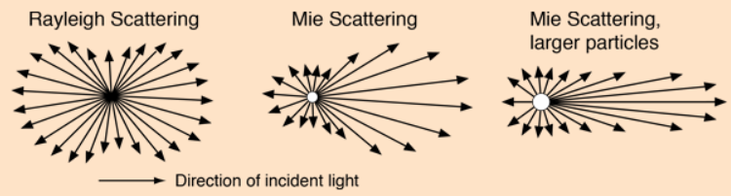

# References

1. <https://aslopubs.onlinelibrary.wiley.com/doi/pdf/10.4319/lo.1988.33.4.0616>
2. <https://www.viseaon.haifa.ac.il/_files/ugd/acdb85_708d3fc222fa492d8e7d2c26f2b5fd5e.pdf>
3. <https://aslopubs.onlinelibrary.wiley.com/doi/epdf/10.4319/lo.1986.31.5.0909>
4. <https://opg.optica.org/oe/fulltext.cfm?uri=oe-11-23-2997&id=77921>
5. <https://opg.optica.org/oe/abstract.cfm?uri=oe-27-12-a766>
6. <https://www.sciencedirect.com/topics/physics-and-astronomy/radiative-transfer-equation>
7. <https://www.britannica.com/science/Rayleigh-scattering>
8. <https://www.sciencedirect.com/topics/chemistry/rayleigh-scattering>
9. <http://hyperphysics.phy-astr.gsu.edu/hbase/atmos/blusky.html#c2>